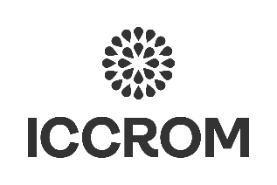

Empowering action for climate through collections-based organizations in ODA countries
2025

Application form
1. APPLICANT INFORMATION
Full name: Click here to enter text.
Nationality: Click here to enter text.
Phone (+ area code): Click here to enter text.
E-mail: Click here to enter text.
Present occupation: Click here to enter text.
Type of collections-based institution you work for: Choose an item.
Institution name: Click here to enter text.
Address: Click here to enter text.
Country: Click here to enter text.
Website: Click here to enter text.

2. COLLECTIONS, CLIMATE ADAPTATION & SUSTAINABILITY-RELATED INFORMATION
Describe the types of collections you work with:
Click here to enter text.

Describe how your place is/will be affected by climate change, and your adaptation aspirations (both to adapt your organization and support local adaptation):
Click here to enter text.

Have you been working with the Sustainable Development Goals (SDGs)? Choose an item.

In 100 words or less, tell us why you want to take part in this programme:
Click here to enter text.

3. OFFICIAL ENDORSEMENT
The undersigned [Name of director institution]
Name of institution: Click here to enter text.
Address: Click here to enter text.
Phone: Click here to enter text.
E-mail: Click here to enter text.
endorses the application of [Applicant name]

This endorsement implies that the organization will support the applicant in undertaking sustainable development-related activities with/around its collections using ICCROM’s Our Collections Matter approaches and tools, as well as their participation in the weekly online workshops in the course of January-February 2025, as indicated in the call for participation.

Signature:
Date: Click or tap to enter a date.

☐ (please tick to confirm) I give consent to the processing of my personal data by ICCROM for candidate selection purposes, including the sharing of profiles with partners and for reviewing and evaluating. Data will be also processed to promote new courses, internships, fellowships, programmes, initiatives, projects, events, round tables or other institutional activities or reports of ICCROM and/or its partners. Users can, at any time, request the erasure of their data at the following e-mail: data-protection@iccrom.org. I also declare to have read in full and understood ICCROM Privacy Policy, including the specific purposes and legal bases of data processing stated therein.

